**Management Principles for Engineers**

***Lecture Notes***



***Compiled By:***

**Career Development Centre**

**SRM IST**

**Table of Contents**

|  |  |
| --- | --- |
|  |  |
| UNIT II | 3 |
| 2.1 Information technology and the new workplace | 3 |
| 2.2 Decision Making Process | 7 |
| 2.3 Planning | 10 |
| 2.4 The planning process | 1 |
| 2.5 Tools, techniques and processes | 14 |

# UNIT II

UNIT II

Information and decision making - Information technology and the new workplace -  Information and decision making - The decision-making process - Planning - Importance of planning  -  The planning process - Types of plans used by - Planning tools, techniques and processes

## 2.1 Information technology and the new workplace

Progressive organisations are doing all they can to design work settings for high performance in an environment where ‘speed to market’, ‘quick response’, ‘fast cycle time’ and ‘time-based competition’ are top priorities.

People work at ‘smart’ stations supported by computers that allow sophisticated voice, image, text and other data-handling operations. Many of these stations are temporary spaces that telecommuters ‘visit’ during those times when they are in the main office; otherwise they work from virtual offices — on the road, anywhere. Voice messaging uses the voice recognition capabilities of computers to take dictation, answer the telephone and relay messages. Databases are easily accessed and shared to solve problems, and to prepare and analyse reports.

Documents drafted via word processing are stored for later retrieval and/or sent via electronic mail or facsimile transmission to other people. Filing cabinets are few, and little paper is found. Meeting notes are written on electronic pads or jotted in palm-held electronic diaries. All are easily uploaded into computer files. Mail arrives and is routed to its destination via computer, where it is electronically prioritized according to its importance and linked to relevant databases to speed problem-solving. Computer conferencing and videoconferencing are commonplace. E-meetings allow people separated by great distances — distributed even around the world — to work together on projects every day without meeting personally face to face.

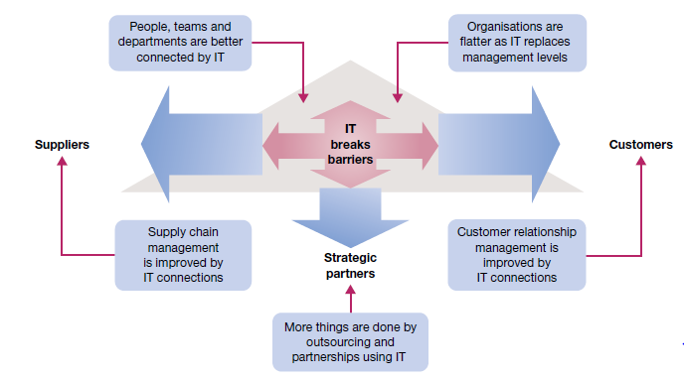

**Fig 2.1.1 Information systems and the nature of managerial work**

**Information technology and the changing business**

One of the most significant business developments of all time is **electronic commerce**, or ‘e-commerce’

The stages of development in e‐commerce are as follows.

1. *Secure an online identity*. Organisations at this stage have a web address and most likely a posted home page.

2. *Establish a web presence*. Organisations at this stage use their home page for advertising or promotional purposes; it offers company and/or product information, but does not allow visitors online queries or ordering.

3. *Enable e‐commerce*. Organisations at this stage are viable e‐commerce businesses whose websites allow visitors to order products online.

4. *Provide e‐commerce and customer relationship management*. Organisations at this stage use their websites to develop and maintain relationships with customers by serving key processes, such as checking status of orders or inventory levels online.

5. *Use a service application model*. Organisations at this stage use advanced website capabilities to fully serve business functions and processes such as financial management and human resources.

**2.1.1 Information and Information systems**

**Information systems** use the latest in information technology to collect, organise and distribute data in such a way that they become meaningful as information. The integration of information systems is an essential element of high productivity.

The five essential characteristics of useful information are as follows.

i. *Timeliness*. The information is available when needed; it meets deadlines for decision-making and action.

ii. *Quality*. The information is accurate and reliable; it can be used with confidence.

iii. *Completeness*. The information is complete and sufficient for the task at hand; it is as current and as up to date as possible.

iv. *Relevance*. The information is appropriate for the task at hand; it is free from extraneous or irrelevant material.

v. *Understandability*. The information is presented in proper form, easily understood by the user; it is free from unnecessary detail; and the scope of the collected information is neither too narrow nor too broad.

A **decision support system (DSS)** allows users to interact directly with a computer to organise and analyse data for solving complex and sometimes unstructured problems. Decision support systems are now available to help with such business decisions as mergers and acquisitions, plant expansions, new product developments and share portfolio management, among many others.

**Expert systems** mimic the thinking of human experts and, in so doing, offer consistent and ‘expert’ decision-making advice to the user.

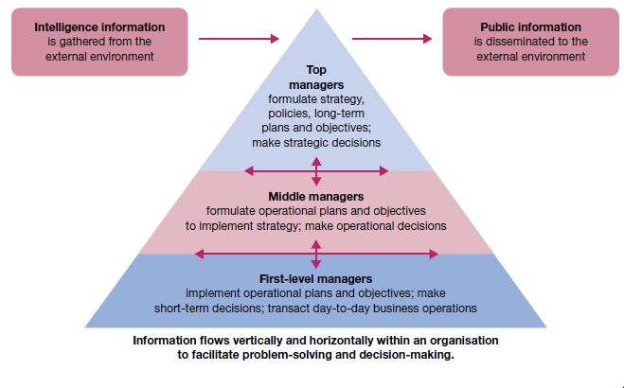

**Fig 2.1.2 External and internal information needs of organisations**

Central to the electronic office is the integration of computers and software into networks that allow users to easily transfer and share information through computer‐to‐computer linkages. It is now very common for organisations to have **intranets** and **corporate portals** that allow employees, by password access, to share databases and communicate electronically, from anywhere in the world. These networks of computers use special software to allow people working in various locations for the same organization to share databases and communicate electronically. The goal is to promote more integration across the organisation and improve operational efficiency and quality.

Fully integrated **extranets** and **enterprise portals** that allow communication and data sharing between the organisation and special elements in its external environment.

**Electronic Data Interchange**, or EDI. It uses controlled access to enterprise portals and supporting software to enable firms to transact business electronically with one another; for example, by sharing purchase orders, bills, receipt confirmations and payments. The goals of EDI include improved transaction speed and cost savings.

**2.1.2 Information and Decision Making**

A **decision**, to be precise, is a choice between alternative courses of action. The process of decision‐making is driven in part by the quality of information available. Information systems help managers to gather data, turn them into useful information, and use that information to make effective problem‐solving decisions.

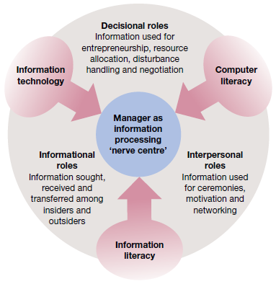

**Fig 2.1.3 Information technology is breaking down barriers and changing organizations**

**Types of managerial decisions**

**Programmed decisions** — that is, solutions already available from past experience to solve problems that are familiar, straightforward and clear with respect to information needs. These decisions apply best to problems that are matters of routine; although perhaps not predictable, they can at least be anticipated. This means that decisions can be planned or programmed in advance, to be implemented as needed.

Unstructured problems require **non-programmed decisions** that craft novel solutions to meet the demands of the unique situation at hand. Most problems faced by higher level managers are of this type, with the problems often involving choice of strategies and objectives in situations of some uncertainty.

**Decision conditions**

People in organisations make decisions under each of the three conditions environments of certainty, risk and uncertainty.

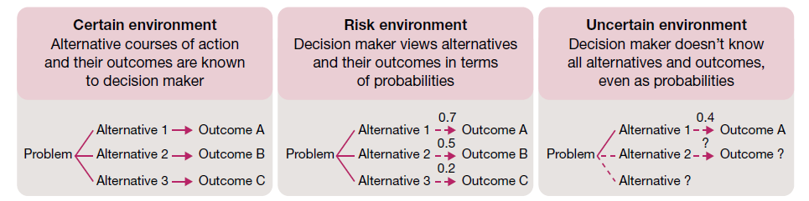

**2.1.4Three environments for managerial decision‐making and problem‐solving**

## 

## Approaching Decisions

People display three quite different approaches or ‘styles’ in the way they deal with problem situations. Some are *problem avoiders* who ignore information that would otherwise signal the presence of an opportunity or performance deficiency. Such people are inactive and do not want to make decisions and deal with problems.

*Problem solvers*, in contrast, are willing to make decisions and try to solve problems, but only when forced to by the situation. They are *reactive* in gathering information and responding to problems after they occur.

*Problem seekers* actively process information and constantly look for problems to solve or opportunities to explore. True problem seekers are *proactive* and forward thinking; they anticipate problems and opportunities and take appropriate action to gain the advantage. Success at problem seeking is one of the ways exceptional managers distinguish themselves.

Another distinction in the way managers approach decisions contrasts tendencies towards ‘systematic’ and ‘intuitive’ thinking. In **systematic thinking** a person approaches problems in a rational, step‐by‐step and analytical fashion. This type of thinking involves breaking a complex problem into smaller components and then tackling them in a logical and integrated fashion. Managers who are systematic can be expected to make a plan before taking action and then to search for information to facilitate problem solving in a step‐by‐step fashion.

Someone using **intuitive thinking**, on the other hand, is more flexible and spontaneous and may also be quite creative. This type of thinking allows us to respond imaginatively to a problem based on a quick and broad evaluation of the situation and the possible alternative courses of action. Managers who are intuitive can be expected to deal with many aspects of a problem at once, jump quickly from one issue to another and consider ‘hunches’ based on experience or spontaneous ideas. This approach tends to work best in situations of high uncertainty where facts are limited and few decision precedents exist.

## 2.2 Decision Making Process

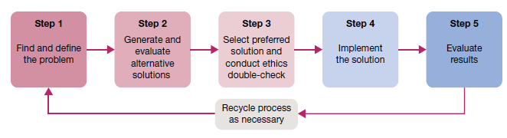

Fig 2.2.1 Steps in decision making and problem solving

***Decision making step 1: Identify and define the problem***

The first step in decision making is to find and define the problem. This is a stage of information gathering, information processing and deliberation.The way a problem is originally defined can have a major impact on how it is eventually resolved. Three common mistakes may occur at this vital first step in decision-making. *Mistakenumber 1* is defining the problem too broadly or too narrowly. To take a classic example, the problem stated as ‘build a better mousetrap’ might be better defined as ‘get rid of the mice’. That is, managers should define problems so as to give themselves the best possible range of problem-solving options. *Mistake number 2* is focusing on symptoms instead of causes. Symptoms are indicators that problems may exist, but they shouldn’t be mistaken for the problems themselves. Managers should be able to spot problem symptoms (e.g. a drop in performance). But instead of treating the symptoms (such as simply encouraging higher performance), managers should deal with their root causes (such as discovering the workers’ need for training in the use of a complex new computer system). *Mistake number 3* is choosing the wrong problem to deal with. Managers should set priorities and deal with the most important problems first. They should also give priority to problems that are truly solvable.

***Decision making step 2: Generate and evaluate possible solutions***

Once the problem is defined, it is possible to formulate one or several potential solutions. At this stage, more information is gathered, data are analysed, and the pros and cons of possible alternative courses of action are identified. This effort to locate, clarify and evaluate alternative solutions is important to successful problem-solving. The involvement of other people is vital here in order to maximise information and build commitment. The end result can only be as good as the quality of the alternative solutions generated in this step. The better the pool of alternatives, the more likely a good solution will be achieved. Common errors in this stage include selecting a particular solution too quickly and choosing an alternative that, although convenient, has damaging side effects or is not as good as others that might be discovered with extra effort. The analysis of alternatives should determine how well each possible course of action deals with the problem while taking into account the environment within which the problem exists. A very basic evaluation involves **cost–benefit analysis**, the comparison of the cost of an alternative and the expected benefits. At a minimum, the benefits of a chosen alternative should be greater than its costs. Typical criteria for evaluating alternatives include the following.

* *Benefits*. What are the ‘benefits’ of using the alternative to solve a performance deficiency or take advantage of an opportunity?
* *Costs*. What are the ‘costs’ of implementing the alternative, including resource investments as well as potential negative side effects?
* *Timeliness*. How fast will the benefits occur and a positive impact be achieved?
* *Acceptability*. To what extent will the alternative be accepted and supported by those who must work with it?
* *Ethical soundness*. How well does the alternative meet acceptable ethical criteria in the eyes of the various stakeholders?

***Decision making step 3: Choose a solution***

At this point in the decision-making process an actual decision is made to select a particular course of action. Just how this is done and by whom must be successfully resolved in each problem situation. Management theory recognises differences between the classical model and the behavioural model of decision-making, as shown in figure. The **classical decision model** views the manager as acting in a certain world. Here, the manager faces a clearly defined problem and knows all possible action alternatives as well as their consequences. As a result, he or she makes an **optimising decision** that gives the absolute best solution to the problem. The classical approach is a very rational model that assumes perfect information is available for decision-making.

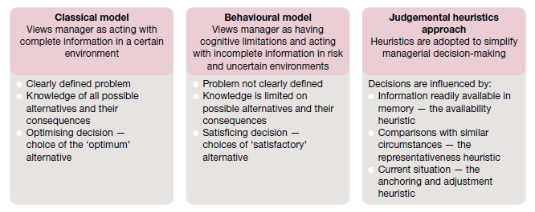

**Fig 2.2.2 Classical, behavioural and judgemental heuristics approaches in decision‐making**

***Decision making step 4: Implement the solution***

Given the choice of preferred solution, appropriate actions must be taken to fully implement it. This is the stage at which directions are finally set and problem‐solving actions are initiated. Nothing new can or will happen according to plan unless action is taken. Managers not only need the determination and creativity to arrive at a decision, they also need the ability and willingness to implement it.

The ‘ways’ in which previous steps have been accomplished can have an additional and powerful impact at this stage of implementation. Difficulties at this stage often trace to the lack‐of‐participation error, or the failure to adequately involve those people whose support is necessary to ensure a decision’s complete implementation. Managers who use participation wisely get the right people involved in decisions and problem‐solving from the beginning. When they do, implementation typically follows quickly, smoothly and to everyone’s satisfaction. Involvement not only makes everyone better informed, it also builds the commitments needed for implementation.

***Decision making step 5: Evaluate results***

The decision‐making process is not complete until results are evaluated. If the desired results are not achieved, the process must be renewed to allow for corrective actions. In this sense, evaluation is a form of managerial control. It involves a continuing commitment to gather information on performance results. Both the positive and negative consequences of the chosen course of action should be examined.

If the original solution appears inadequate, a return to earlier steps in problem‐solving may be required to generate a modified or new solution. In this way, problem‐solving becomes a dynamic and ongoing activity within the management process. Evaluation is also made easier if the solution involves clear objectives that include measurable targets and timetables.

## 2.3 Planning

Planning involves selecting missions and objectives and the actions to achieve them, it requires decision-making that is choosing future courses of action from among alternatives. Plans thus provide a rational approach to achieving pre-selected objectives.

The role of the planning function in the management process

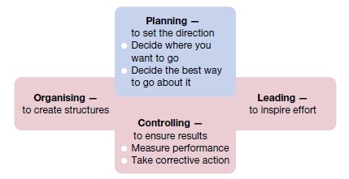

**2.3.1 The role of the planning function in the management process**

**Types of Plans**

***mission or purpose***

the mission or purpose identifies the basic function or the task of an enterprise or an agency or any part of it.

***Objectives***

This is the first step in planning the action plan of the organization. Objectives are the basics of every company and the desired objective/result that the company plans on achieving, so they are the endpoint of every planning activity.

For example one of the objectives of an organization could be to increase sales by 20%. So the manager will plan all activities of the organization with this end objective in mind. While framing the objectives of the organization some points should be kept in mind.

* Objectives should be framed for a single activity in mind.
* They should be result oriented. The objective must not frame any actions
* Objectives should not be vague, they should be quantitative and measurable.
* They should not be unrealistic. Objectives must be achievable.

***Strategy***

This obviously is the next type of plan, the next step that follows objectives. A strategy is a complete and all-inclusive plan for achieving said objectives. A strategy is a plan that has three specific dimensions

1. Establishing long-term objectives
2. Selecting a specific course of action
3. allocating the necessary resources needed for the plan

Forming strategy is generally reserved for the top level of management. It actually defines all future decisions and the company’s long-term scope and general direction.

***Policy***

Policies are generic statements, which are basically a guide to channelize energies towards a particular strategy. It is an organization’s general way of understanding, interpreting and implementing strategies. Like for example, most companies have a return policy or recruitment policy or pricing policy etc.

Policies are made across all levels of management, from major policies at the top-most level to minor policies. The managers need to form policies to help the employees navigate a situation with predetermined decisions. They also help employees to make decisions in unexpected situations.

***Procedure***

Procedures are the next types of plan. They are a stepwise guide for the routine to carry out the activities. These stepwise sequences are to be followed by all the employees so the activities can be fulfilled in an organized manner.

The procedures are described in a chronological order. So when the employees follow the instructions in the order and completely, the success of the activity is pretty much guaranteed.

Take for example the procedure of admission of a student in a college. The procedure starts with filling out an application form. It will be followed by a collection of documents and sorting the applications accordingly.

***Rules***

Rules are very specific statements that define an action or non-action. Also, rules allow for no flexibility at all, they are final. All employees of the organization must compulsorily follow and implement the rules. Not following rules can have severe consequences.

Rules create an environment of discipline in the organization. They guide the actions and the behaviour of all the employees of the organization. The rule of “no smoking” is one such example.

***Program***

Programmes are an in-depth statement that outlines a company’s policies, rules, objectives, procedures etc. These programmes are important in the implementation of all types of plan. They create a link between the company’s objectives, procedures and rules.

Primary programmes are made at the top level of management. To support the primary program all managers will make other programs at the middle and lower levels of management.

***Methods***

Methods prescribe the ways in which in which specific tasks of a procedure must be performed. Also, methods are very specific and detailed instructions on how the employees must perform every task of the planned procedure. So managers form methods to formalize routine jobs.

Methods are very important types of plan for an organization. They help in the following ways

* give clear instructions to the employees, removes any confusion
* Ensures uniformity in the actions of the employees
* Standardizes the routine jobs
* Acts as an overall guide for the employees and the managers

***Budget***

A budget is a statement of expected results the managers expect from the company. Budgets are also a quantitative statement, so they are expressed in numerical terms. A budget quantifies the forecast or future of the organization.

There are many types of budgets that managers make. There is the obvious financial budget, that forecasts the profit of the company. Then there are operational budgets generally prepared by lower-level managers. Cash budgets monitor the cash inflows and outflows of the company.

## 2.4 The planning process

The planning process begins with an organisation identifying specific outcomes that it wishes to achieve. It may set different targets depending on the environment it encounters, especially where the environment is uncertain or changing rapidly. This ‘what-if’ or scenario planning is practised by an increasing number of organisations. Organisations may also include in their plans action to help shape or stabilize the environment. Such action could include lobbying governments locally and overseas, creating industry networks, or philanthropy. The organisation’s **plan** is a statement of the actual steps required to achieve its objectives. There are five sequential action steps in the systematic planning process.

**1. *Define your objectives*.** Identify desired outcomes or results in very specific ways. Know where you want to go; be specific enough that you will know you have arrived when you get there or know how far off the mark you are at various points along the way.

**2. *Determine where you currently stand in relation to objectives*.** Evaluate current accomplishments relative to the desired results. Know where you stand in reaching the objectives; know what strengths work in your favour and what weaknesses may hold you back.

**3. *Develop perspectives regarding future conditions*.** Try to forecast potential future events. Generate alternative ‘scenarios’ for what may happen; identify for each scenario things that may help or hinder progress towards your objectives. Systematically vary the drivers for each scenario to determine possible outcomes.

**4. *Analyse and choose among action alternatives*.** List and carefully evaluate the possible actions that may be taken. Choose the alternative(s) most likely to accomplish your objectives; describe step by step what must be done to follow the chosen course of action.

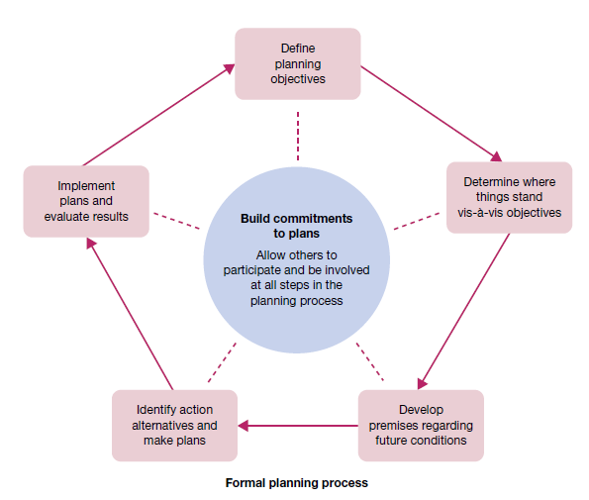

**Fig 2.4.1 How participation and involvement help build commitments to plans**

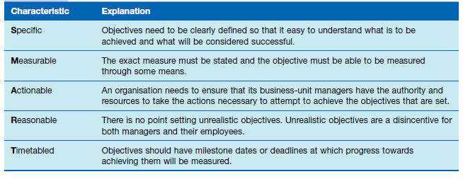

**Fig 2.4.2 The SMART model of establishing effective organisational objectives**

**5. *Implement the plan and evaluate results***. Take action and carefully measure your progress towards objectives.

Do what the plan requires; evaluate results; take corrective action, and revise plans as needed. The planning process described is an application of the decision-making process introduced in the chapter on information and decision-making. It is a systematic way to approach two important tasks: setting performance objectives, and deciding how to best achieve them. Importantly, in the complex setting of the modern workplace this is not a process that managers do while working alone in quiet rooms, free from distractions, and at scheduled times. Rather, planning should be part of a manager’s everyday work routine. It should be an ongoing activity that is done continuously even while dealing with an otherwise hectic and demanding work setting.6 Importantly, the best planning in management always involves those people whose work efforts will eventually determine whether the objectives are accomplished.

* + 1. **Features Of Planning**

**Planning is Goal Oriented:**

All plans arise from objectives. Objectives provide the basic guidelines for planning activities. Planning has no meaning unless it contributes in some positive manner to the achieve­ment of predetermined goals.

**Planning is a Primary Function:**

Planning is the foundation of manage­ment. It is a parent exercise in management process. It is a preface to business activities. According to Koontz, “Planning provides the basic foundation from which all future management functions arise”.

**Planning is All Pervasive:**

Planning is a function of all managers. It is needed and practiced at all managerial levels. Planning is inherent in everything a manager does.

**Planning is a Mental Exercise:**

Planning is a mental process involving imagination, foresight and sound judgment. Planning compels managers to abandon guesswork and wishful thinking. It makes them think in a logical and systematic manner.

**Planning is a Continuous Process:**

Planning is continuous. It is a never-end­ing activity. It is an ongoing process of adjustment to change. There is always need for a new plan to be drawn on the basis of new demands and changes in the circumstances.

**Planning Involves Choice:**

Planning essentially involves choice among various alternative courses of action. If there is one way of doing some­thing, there is no need for planning. The need for planning arises only when alternatives are available.

**Planning is Forward Looking:**

Planning means looking ahead and pre­paring for the future. It means peeping into the future, analyzing it and preparing for it. Managers plan today with a view to flourish tomorrow. Without planning, business becomes random in nature and decisions would become meaningless, adhoc choices.

**Planning is Flexible:**

Planning is based on a forecast of future events. Since future is uncertain, plans should be reasonably flexible. When market conditions change, planners have to make necessary changes in the existing plans.

**Planning is an Integrated Process:**

Plans are structured in a logical way wherein every lower-level plan serves as a means to accomplish higher level plans. They are highly interdependent and mutually supportive.

**Planning Includes Efficiency and Effectiveness Dimensions:**

Plans aim at deploying resources economically and efficiently. They also try to ac­complish what has been actually targeted. The effectiveness of plans is usually dependent on how much it can contribute to the predetermined objectives.

**2.4.2 Importance Of Planning**

***Increases efficiency:*** Planning makes optimum utilization of all available resources. It helps to reduce the wastage of valuable resources and avoids their duplication. It aims to give the highest returns at the lowest possible cost. It thus increases the overall efficiency.

***Reduces business-related risks:*** There are many risks involved in any modern business. Planning helps to forecast these business-related risks. It also helps to take the necessary precautions to avoid these risks and prepare for future uncertainties in advance. Thus, it reduces business risks.

***Facilitates proper coordination:*** Often, the plans of all departments of an organization are well coordinated with each other. Similarly, the short-term, medium-term and long-term plans of an organization are also coordinated with each other. Such proper coordination is possible only because of efficient planning.

***Aids in Organizing:*** Organizing means to bring together all available resources, i.e. 6 Ms. Organizing is not possible without planning. It is so, since, planning tells us the number of resources required and when are they needed. It means that planning aids in organizing in an efficient way.

***Gives right direction:*** Direction means to give proper information, accurate instructions and useful guidance to the subordinates. It is impossible without planning. It is because planning tells us what to do, how to do it and when to do it. Therefore, planning helps to give the right direction.

***Keeps good control:*** With control, the actual performance of an employee is compared with the plans, and deviations (if any) are found out and corrected. It is impossible to achieve such control without the right planning. Therefore, planning becomes necessary to keep good control.

***Helps to achieve objectives:*** Every organization has certain objectives or targets. It keeps working hard to fulfill these goals. Planning helps an organization to achieve these aims, but with some ease and promptness. Planning also helps an organization to avoid doing some random ( done by chance) activities.

***Motivates personnel:*** A good plan provides various financial and non-financial incentives to both managers and employees. These incentives motivate them to work hard and achieve the objectives of the organization. Thus, planning through various incentives helps to motivate the personnel of an organization.

***Encourages creativity and innovation:*** Planning helps managers to express their creativity and innovation. It brings satisfaction to the managers and eventually a success to the organization.

***Helps in decision-making:*** A manager makes many different plans. Then the manager selects or chooses the best of all available strategies. Making a selection or choosing something means to take a decision. So, decision-making is facilitated by planning.

## 2.5 Tools, techniques and processes

Today’s planners use a broad array of planning tools, techniques and processes. These include forecasting, specific contingency planning, benchmarking, participatory or team-based planning, and staff planners.

**Forecasting**

A forecast is a vision of the future. Forecasting is the process of making assumptions about what will happen in the future.15 All good plans involve forecasts, either implicit or explicit. Some forecasts are based on *qualitative forecasting*, which uses expert opinions to predict the future. In this case, a single person of special expertise or reputation or a panel of experts may be consulted. Others involve *quantitative forecasting* that uses mathematical and statistical analysis of data banks to predict future events. Time-series analysis makes predictions by using statistical routines such as regression analysis to project past trends into the future. General economic trends are often forecast by econometric models that simulate events and make predictions based on relationships discovered among variables in the models. Statistical analysis of opinion polls and attitude surveys, such as those reported in newspapers and on television, is typically used to predict future consumer tastes, employee preferences and political choices, among other issues. In the final analysis, forecasting always relies on human judgement.

**Contingency planning**

Activity undertaken to ensure that proper and immediate follow-up steps will be taken by a management and employees in an emergency. Its major objectives are to ensure (1) containment of damage or injury to, or loss of, personnel and property, and (2) continuity of the key operations of the organization. Contingency planning identifies alternative courses of action that can be implemented if and when an original plan proves inadequate because of changing circumstances.

**Scenario planning and contingency planning**

Scenario planning is the long-term version of contingency planning. Identifying a range of different possible future scenarios helps organisations operate more flexibly and respond more rapidly in uncertain and changing environments.

**Benefits of scenario planning**

Scenario planning is not forecasting what planners think will happen. Rather, it consists of developing possible plausible scenarios of the future, with reference to a particular firm, that make different assumptions about forces driving the market and including different uncertainties.16 This allows the manager or planner to consider how these environmental uncertainties might affect the firm’s strategy, and thus to plan for such eventualities should they occur.

Scenario planning improves focus and flexibility

Scenario planning improves action orientation

Scenario planning improves coordination

Scenario planning improves time management

Scenario planning improves control

**Benchmarking**

Another important influence on the success or failure of planning involves the frame of reference used as a starting point. All too often planners have only a limited awareness of what is happening outside the immediate work setting. Successful planning must challenge the status quo; it cannot simply accept things the way they are. One way to do this is through benchmarking, a technique that makes use of external comparisons to better evaluate an organisation’s current performance and identify possible actions for the future. The purpose of benchmarking is to find out what other people and organizations are doing very well and then to plan how to incorporate these ideas into your organisation’s operations

This powerful planning technique is increasingly popular in today’s competitive business world. It is a way for progressive companies to learn from other ‘excellent’ companies, not just competitors. It allows them to analyse and thoroughly compare all systems and processes for efficiencies and opportunities for innovation.

**Staff planners**

As the planning needs of organisations grow, there is a corresponding need to increase the sophistication of the overall planning system itself. In some cases, staff planners are employed to help coordinate planning for the organisation as a whole or for one of its major components. These planners should be skilled in all steps of the formal planning process, including the benchmarking and scenario-planning approaches just discussed. They should also understand the advisory nature of their roles. Given clear responsibilities and their special planning expertise, staff planners can bring focus to efforts to accomplish important planning tasks. But one risk is a tendency for a communication ‘gap’ to develop between staff planners and line managers. This can cause a great deal of difficulty. Resulting plans may lack relevance, and line personnel may lack commitment to implement them even if they are relevant. One trend in organisations today is to de-emphasise the role of large staff planning groups and to place much greater emphasis on the participation and involvement of line managers in the planning process.

**Management by objectives**

A useful planning technique that helps integrate planning and controlling is management by objectives, or just MBO. This is a structured process of regular communication in which a manager or team leader works with staff or team members to jointly set performance objectives and review results accomplished. MBO creates an agreement between the two parties regarding:

1. Performance objectives for a given time period

2. Plans through which they will be accomplished

3. Standards for measuring whether they have been accomplished

4. Procedures for reviewing performance results.

Of course, both parties in any MBO agreement are supposed to work closely together to fulfil the terms of the agreement.

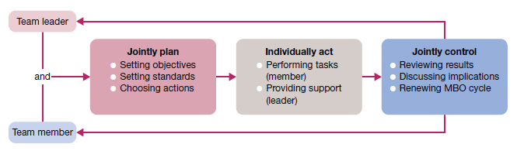

**Fig 2.5.1 Performance objectives in MBO**

**Participation and involvement**

Planning is a process, not an event, and ‘participation’ is a key component of the planning process. Participatory planning means that the process includes people who will be affected by the resulting plans and/or who will be asked to help implement them. This brings to the organisation many benefits. Participation can increase the creativity and information available for planning. It can also increase the understanding, acceptance and commitment of people to final plans. Indeed, planning should be organized and accomplished in a participatory manner that includes the contributions of many people representing diverse responsibilities and vantage points. This includes the level of strategic planning, once considered only the province of top management. The more aware all levels are of strategic plans and the more they are involved in helping to establish them, the greater the commitment throughout the organisation to their accomplishment.

**Planning Process alternate content**

1] Recognizing Need for Action

An important part of the planning process is to be aware of the business opportunities in the firm’s external environment as well as within the firm. Once such opportunities get recognized the managers can recognize the actions that need to be taken to realize them. A realistic look must be taken at the prospect of these new opportunities and SWOT analysis should be done.

Say for example the government plans on promoting cottage industries in semi-urban areas. A firm can look to explore this opportunity.

2] Setting Objectives

This is the second and perhaps the most important step of the planning process. Here we establish the objectives for the whole organization and also individual departments. Organizational objectives provide a general direction, objectives of departments will be more planned and detailed.

Objectives can be long term and short term as well. They indicate the end result the company wishes to achieve. So objectives will percolate down from the managers and will also guide and push the employees in the correct direction.

3] Developing Premises

Planning is always done keeping the future in mind, however, the future is always uncertain. So in the function of management certain assumptions will have to be made. These assumptions are the premises. Such assumptions are made in the form of forecasts, existing plans, past policies, etc.

These planning premises are also of two types – internal and external. External assumptions deal with factors such as political environment, social environment, the advancement of technology, competition, government policies, etc. Internal assumptions deal with policies, availability of resources, quality of management, etc.

These assumptions being made should be uniform across the organization. All managers should be aware of these premises and should agree with them.

4] Identifying Alternatives

The fourth step of the planning process is to identify the alternatives available to the managers. There is no one way to achieve the objectives of the firm, there is a multitude of choices. All of these alternative courses should be identified. There must be options available to the manager.

Maybe he chooses an innovative alternative hoping for more efficient results. If he does not want to experiment he will stick to the more routine course of action. The problem with this step is not finding the alternatives but narrowing them down to a reasonable amount of choices so all of them can be thoroughly evaluated.

5] Examining Alternate Course of Action

The next step of the planning process is to evaluate and closely examine each of the alternative plans. Every option will go through an examination where all there pros and cons will be weighed. The alternative plans need to be evaluated in light of the organizational objectives.

For example, if it is a financial plan. Then it that case its risk-return evaluation will be done. Detailed calculation and analysis are done to ensure that the plan is capable of achieving the objectives in the best and most efficient manner possible.

6] Selecting the Alternative

Finally, we reach the decision making stage of the planning process. Now the best and most feasible plan will be chosen to be implemented. The ideal plan is the most profitable one with the least amount of negative consequences and is also adaptable to dynamic situations.

The choice is obviously based on scientific analysis and mathematical equations. But a managers intuition and experience should also play a big part in this decision. Sometimes a few different aspects of different plans are combined to come up with the one ideal plan.

7] Formulating Supporting Plan

Once you have chosen the plan to be implemented, managers will have to come up with one or more supporting plans. These secondary plans help with the implementation of the main plan. For example plans to hire more people, train personnel, expand the office etc are supporting plans for the main plan of launching a new product. So all these secondary plans are in fact part of the main plan.

8] Implementation of the Plan

And finally, we come to the last step of the planning process, implementation of the plan. This is when all the other functions of management come into play and the plan is put into action to achieve the objectives of the organization. The tools required for such implementation involve the types of plans- procedures, policies, budgets, rules, standards etc.